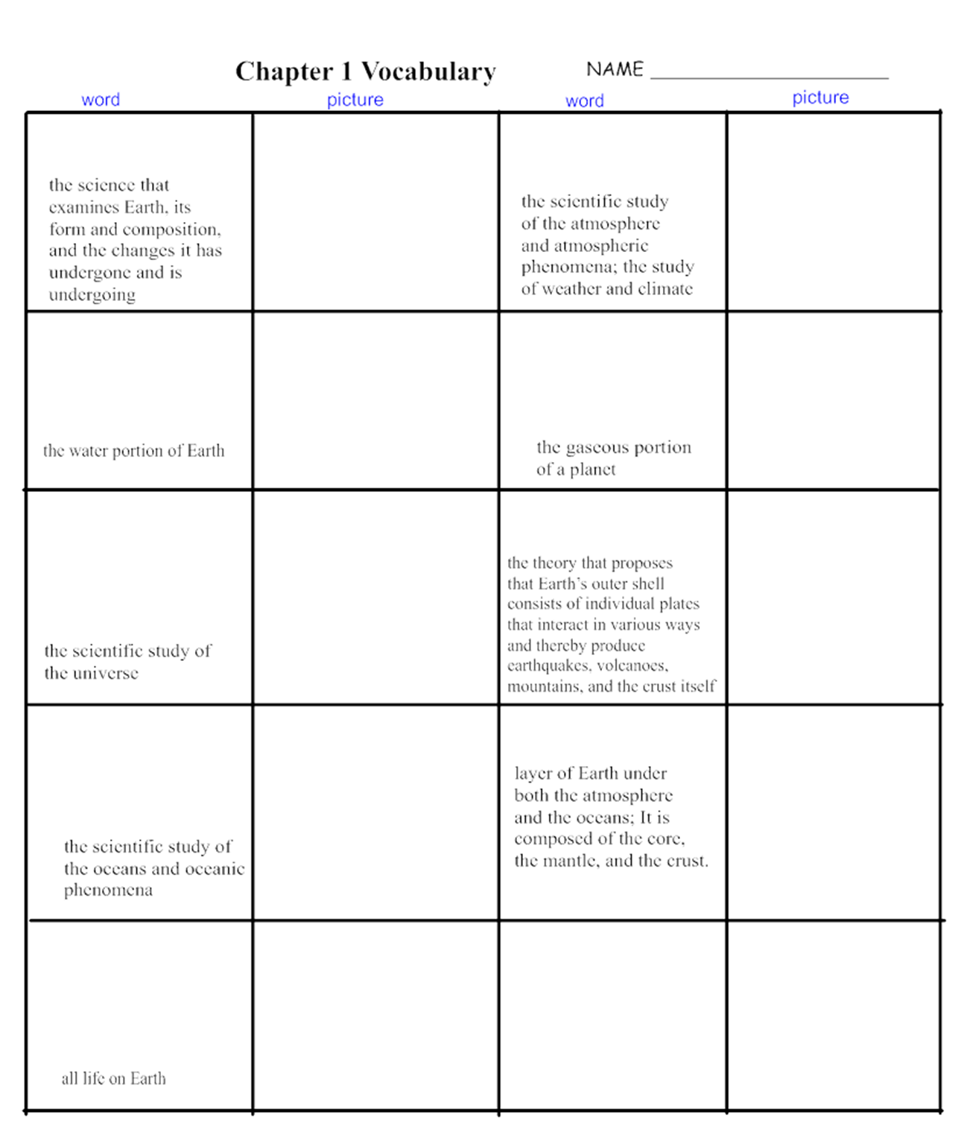

Make the following conversions:



1) 34.78 g = mg 1,345,000 mm = hm

2) 0.45 hl = l 143.67 cm = dam

3) 5 cl = kg 8.4 kg = cg

4) 0.0087 ml = hl 4500 cm = m

5) 683.5 g = dg 4.67 g = dag

6) 3.4 m = mm 0.000076 dg = dag

7) 603,000,000 kl = l 135 cm3 = ml

Convert the following from scientific notation as was done in examples A & B:

1) 5.2 x 105 = 4) 9.8 x 107 =

2) 4 x 10-5 = 5) 2.8 x 10-4 =

3) 8.6 x 10-3 = 6) 6 x 10-9 =

Convert the following numbers into scientific notation as was done in examples C & D:

7) 895 000 000 000 = 10) 0.000 000 58 =

8) 120 000 000 = 11) 0.000 000 782 =

9) 958 000 000 = 12) 0. 000 63 =

