NAME Block ____ Binder Page #______

Interior Processes Study Guide
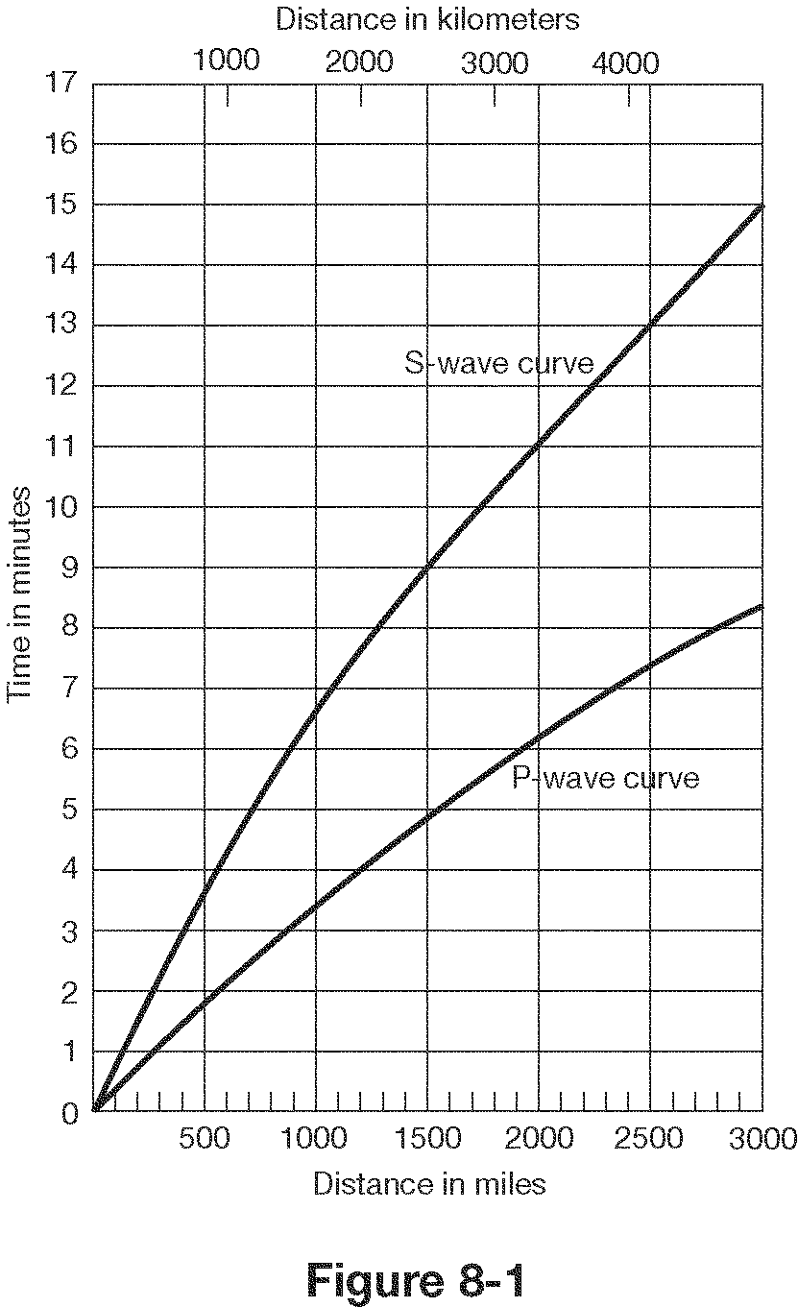

- How far does a P wave travel in 2 minutes? 600 mi
- How far does an S wave travel in 4 minutes? 600 mi
- How long does it take a P wave to travel 1500 miles? 5 min
- What is the lag time between P and S waves at 2000 km? 5 min
- What is the lag time for P and S waves at the epicenter? 0 sec
- If there is a lag time of 4.5 minutes between P and S waves, how far is the epicenter? 1750 mi
- If there is a lag time of 2 minutes between P and S waves, how far is the epicenter? 500 mi

Write P, S or Surface(L)
- Fastest waves- P
- Slowest waves- Surface
- Only travel through solids- S
- Cause the most damage- Surface
- Travel side to side- S
- Push-Pull or compression waves- P
- Can’t make it through the outer core- S

15. The difference in the Arrival Times of P waves and S waves is used to locate an earthquake’s epicenter.

16. The amount of damage that results from an earthquake depends on the intensity and duration of the earthquake, the nature of the material on which structures are built, and distance from epicenter.
17. Can we predict earthquakes? No

18. How do earthquakes provide evidence of plate tectonics? Plates are moving, causing vibrations (quakes)

19. List at least four dangers (factors affecting damage) that are associated with earthquakes. Size, Soil type, Location, Building Quality

20. How many seismic stations are needed to locate an earthquake? 3

21. What can we learn from earthquakes? Layers of the earth, distance from epicenter

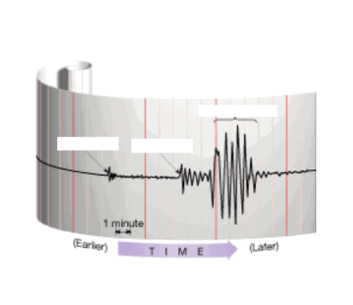

M.

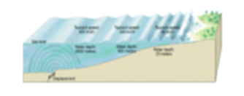
Match the following words with the correct definition and picture: Put both letters on the line.

N.
26. Seismogram - D a. sudden release of energy as deformed rock snaps
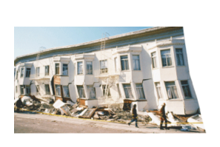
27. Lithosphere - E b. solid layer of Earth under the crust

28. Epicenter - H c. huge wave caused by an underwater earthquake
O.
29. Mantle - B d. a recording of earthquake waves

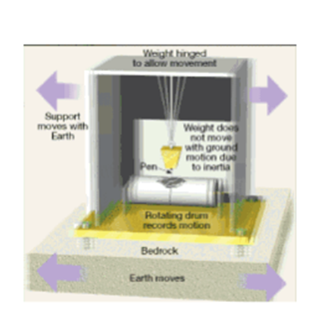
30. Asthenosphere - I e. rigid layer of Earth made of crust and the uppermost mantle

31. Fault - J f. solid innermost part of Earth, made of iron and nickel
P.
32. Focus - K g. liquid layer of the Earth, made of iron and nickel

33. Outer core - G h. surface location of an earthquake

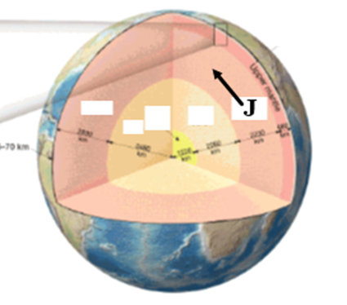
34. Seismograph - L i. semi-molten layer of Earth in the upper mantle

35. Tsunami - C j. crack in the Earth along which movement has occurred
Q.
36. Inner core - F k. underground location of an earthquake, point of origin

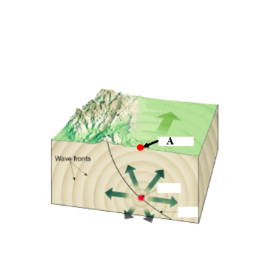
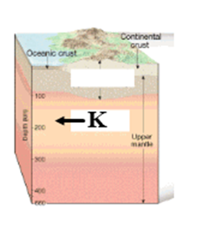
37. Earthquake - A l. devise that measures and records earthquake waves
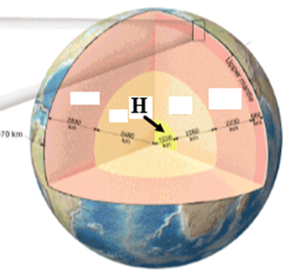
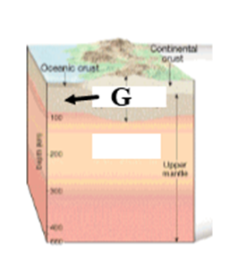
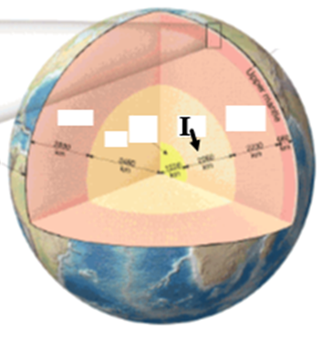
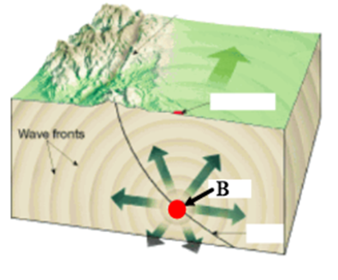
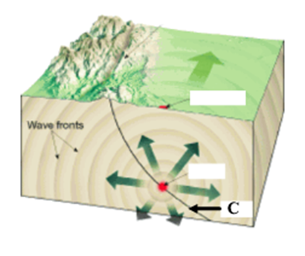

R. S. T. U. V. W. X.

38. What are the main pieces of evidence for plate tectonics?
Sea-floor spreading,
Matching fossils and rock layers and mountain ranges on continents that are far apart,
Magnetic strips on the ocean floor on both sides of the mid-ocean ridge

39. Most earthquakes and volcanoes take place at Plate Boundaries.
40. The Mid-Atlantic Ridge, where plates are moving apart, is an example of a Divergent boundary.
41. Crust is Growing at diverging boundaries and Subducting at converging boundaries.
42. The Himalayas where two continental plates are colliding is an example of a Converging boundary and the Andes Mountains where an ocean plate is being pushed under a continental plate is an example of a Subducting boundary,
meaning the Andes mountains must be Rising while the Himalayas are Rising.
43. Oceanic crust is always subducted under continental crust because it is More Dense.
44. Hawaii is not located on a plate boundary, but it is the most volcanically active place in the world due to a Hot Spot.
45. How do volcanoes provide evidence of plate tectonics? On Plate Boundaries, formed from rising magma from melted subducted crust
46. What things influence the nature of a volcanic eruption?
Type of Magma Gases in the Magma Location of the volcano (hot spot or plate boundary)

What are some warning signs that a volcano may erupt?
More gases being released More frequent earthquakes Land rising/falling
Water on volcano heating up or changing chemically

47. Which volcano below will have an explosive eruption and why?
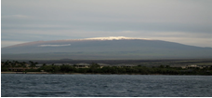
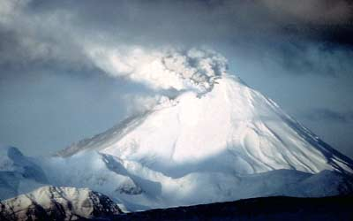
Left (Composite)
Lava has a higher viscosity (traps gas)
And explodes with greater force

On the First Line, Identify the boundaries.
Then, on the Second Line, identify the geologic feature(s) found there.
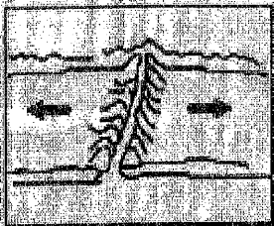
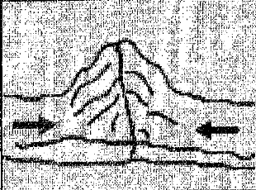
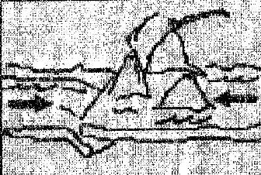
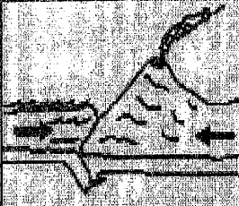

1. 2. 3. 4.
Diverging 4 Collision 1 Subduction (o&o) 2 Subduction (o&c) 3
Mid-Ocean Ridge Mountain Volcanic Islands Volcanoes

- Sea floor spreading is taking place at Divergent Boundaries (above)

- Describe plate motions at:
    - Transform boundaries – Moving Past each other
    - Converging boundaries – Moving Towards each other
    - Diverging boundaries - Moving Away from each other
- What was discovered near the center of the Atlantic Ocean? Mid Ocean Ridge

- What discovery was made in bands of rock on either side of the Mid-Atlantic Ridge?
Bands of Rock had magnetic material in them which pointed North, then the next band had material which pointed South

52. How do these bands support sea-floor spreading? Age of Rock Bands get Older as they get farther from the Mid Ocean Ridge
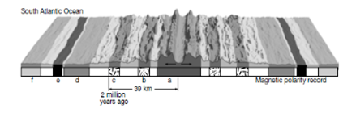

- Thickest sediments on sea floor are located where? Near the Edges

- Youngest rocks on sea floor are located where? Near the Middle (mid ocean ridge)
- What are some warning signs that a volcano may become active in the near future?

More frequent earthquakes, more gases being released, rising/falling land, lava moving below volcano
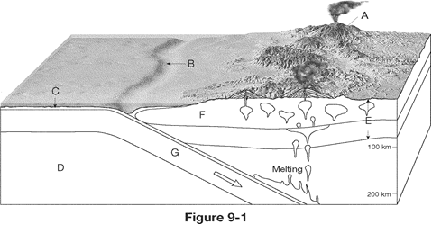

- What type of boundary is shown above?
Convergent (subduction)

- What are the two geologic structures found in the diagram above?
Trench, Volcano

- Which crust is being subducted, and why?
Oceanic – more dense

- What is the cause of the volcanoes in the diagram?
Oceanic crust under continental crust melting and rising through the continental crust

