Energy Transformations Name ________________ block __ Binder # _____
Video Notes

Energy is __________________________________________________________________.

The two categories of energy are ___________________ and _________________.

For each type of energy listed below, describe it, and give an example.

- Types of Potential Energy:
  - Chemical:
  - Nuclear:
  - Stored Mechanical (Also called Elastic Potential):
  - Gravitational:
- Types of Kinetic Energy:
  - Radiant:
  - Thermal:
  - Motion:
  - Sound:
  - Electrical:

The Law of Conservation of Energy states that…

An example of the Law of Conservation of Energy is (Draw/Explain)...

Where did the energy in your food come from?

How is energy converted from one form to another when you drive car? (Draw/Explain)

Describe the energy transformation that is taking place in each scenario.

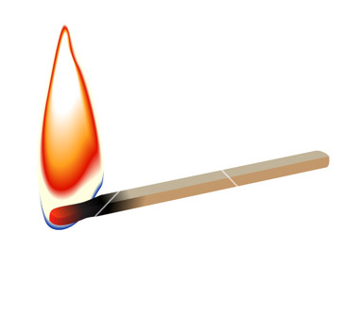
Lighting a match

________________ _________________ and _______________

Exploding Fireworks

_______________ _____________ and ______________ and _______________

Turning on a lightbulb

____________ ______________ and ______________

Kicking a soccer ball (start with the energy the foot)

_____________ ______________ and _______________ and ______________

Learning Checks: NOW YOU TRY!

- ___________________________________________________________________________
- ____________________
- ____________________
- ____________________

