Methane and Global Temperatures
Class Copy – Write your answers on your own paper
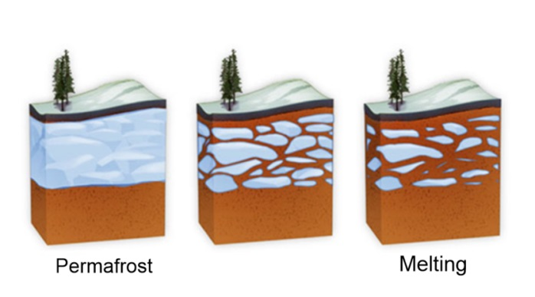
Introduction: Much of the northern latitudes of the earth have been frozen for thousands of years. The ground in these areas is called permafrost as it never melts, even in the warmest part of the year. Organic matter, such as dead trees, grass, or leaves, that falls to the ground does not have the opportunity to decay because of the persistently cold temperatures. Because the organic matter does not decay, it accumulates in the ground or as sediment in lakes.
As global temperatures increase, areas that were once frozen, are beginning to thaw. As the permafrost thaws, bacteria and fungus begin to decompose the organic matter that accumulated in the soil and sediments of lakes. As bacteria and fungus consume the organic matter, they create waste products like methane and CO₂. These two gasses are greenhouse gasses. When they are in the atmosphere, they trap heat near the surface of the earth. The more greenhouse gasses the atmosphere contains, the better it will be at trapping heat near the surface of earth.
Here lies the dilemma: Greenhouse gasses create a warmer planet. This warmer planet allows more permafrost to melt. The melting permafrost allows bacteria and fungus to thrive on the organic matter. These decomposers create more greenhouse gasses as they dine on the organic matter. This is a cycle that speeds up the pace of climate change.
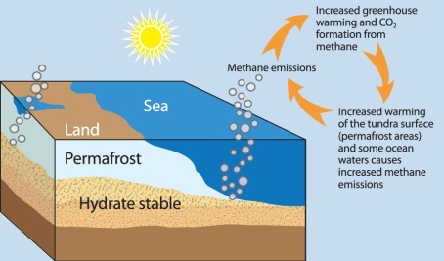
Interpret the diagram:
- What is the source of the methane and CO₂?
- What is the effect of more methane and CO₂ in the atmosphere?
- What is the effect of higher global temperatures on the permafrost?
- When the permafrost melts, what happens to the organic matter in permafrost?
- What is created as the organic matter is digested by bacteria and fungus?
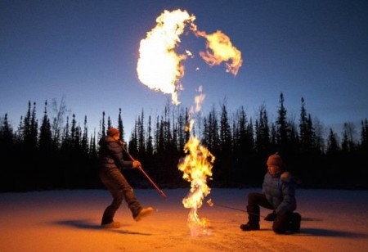
Picture on left: Climate Scientists analyzing the methane that bubbles up and gets trapped beneath the ice. You can poke a hole in the ice and light it on fire! This phenomenon is a result of bacteria and fungus consuming the organic matter in the sediment beneath this lake. The warming climate allows bacterial and fungal growth to occur, amplifying the issue.
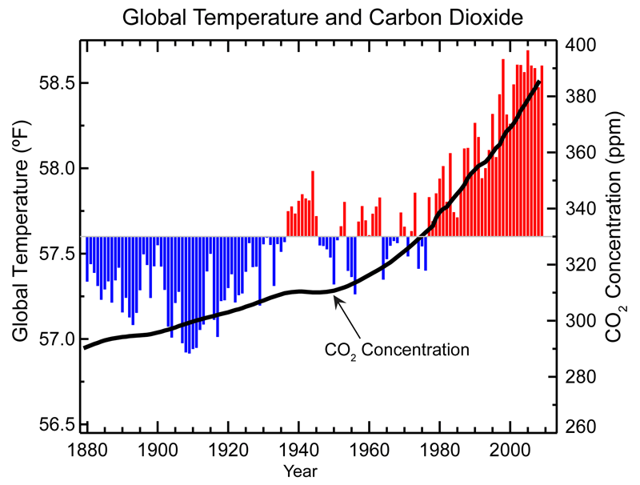
READ: This graph shows the global annual average temperature measured over land and oceans. Red bars indicate temperatures above and blue bars indicate temperatures below the 1901-2000 average temperature. The black line shows atmospheric carbon dioxide concentration in parts per million.

Global average temperature is one of the most-cited indicators of global climate change, and shows an increase of approximately 1.4°F since the early 20th Century. The global surface temperature is based on air temperature data over land and sea-surface temperatures observed from ships, buoys and satellites. There is a clear long-term global warming trend, while each individual year does not always show a temperature increase relative to the previous year, and some years show greater changes than others. These year-to-year fluctuations in temperature are due to natural processes, such as the effects of El Ninos, La Ninas, and the eruption of large volcanoes. Notably, the 20 warmest years have all occurred since 1981, and the 10 warmest have all occurred in the past 12 years.
Interpret the Graph:
- How is the global temperature changing?
- When has the temperature increased the most?
- When was the last year the global temperature was below average (blue)?
- How is the concentration of CO₂ in the atmosphere changing?
- Does the concentration of CO₂ appear to be linked to the global climate?
- Besides the melting of the permafrost, what are 2 other things that are contributing to the rise of CO₂ in the atmosphere?
- Is the process described in this situation a positive or negative feedback loop?

