Name _____________________________________________________ Block ______ Binder Page #______
Layers of the Earth – “Fill in the Blank” Notes
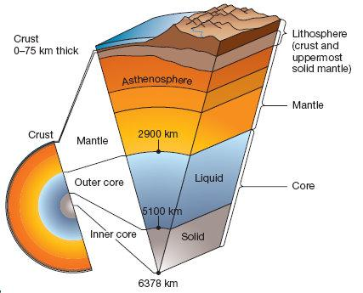
 | Crust | Mantle | Outer Core | Inner Core
Solid/Liquid? | Thin, R________ | H____ / p____________  semi-molten, weak | L___________ | S_________
Thickness/depth | Ocean: _____ km  Continents: up to  ____ km | _________ km | ________ km | ________ km
Temperature |  |  | _____-______  Celsius | ______-______ Celsius
Composition | G_______ / B________ | I______ / M___________ | I______ / N__________ | I______ / N___________
Extra???? |  | C_____________ occurs here |  | solid because of P____________

Lithosphere -S________, T________ layer of E________________
-consists of C__________ and U______________ mantle
Asthenosphere -M_____________ layer of the M______________
-C___________________ cells occur here
Video Notes

Plates Carries C_________________, Ocean Basins, or B_________
Move at an average of __________ inches per year

Convection As M_______________ material moves, it causes P_____________ to move above it as well

Types of Plate Boundaries Divergent: Plates move A_____________
Convergent: Plates move T_______________
Transform: Plates S________ P_______ each other

What happens at Plate Boundaries?
Divergent: *P_______________ move apart
*M____________ rises to fill the G_______
*New C_____________ is added
*Mid-Ocean R____________ is created
Convergent: *Plates move T__________________
A. O____________ plate sinks U____________ continental plate
*Subduction Z__________ created
*Deep T______________
B. Continental plate meets C_____________ plate
*M___________________ formed

