Light Bulb Energy Lab
Does Changing A Light Bulb Really Make A Difference?
Revised from Red Rocks Green Apps by Barbara Maher
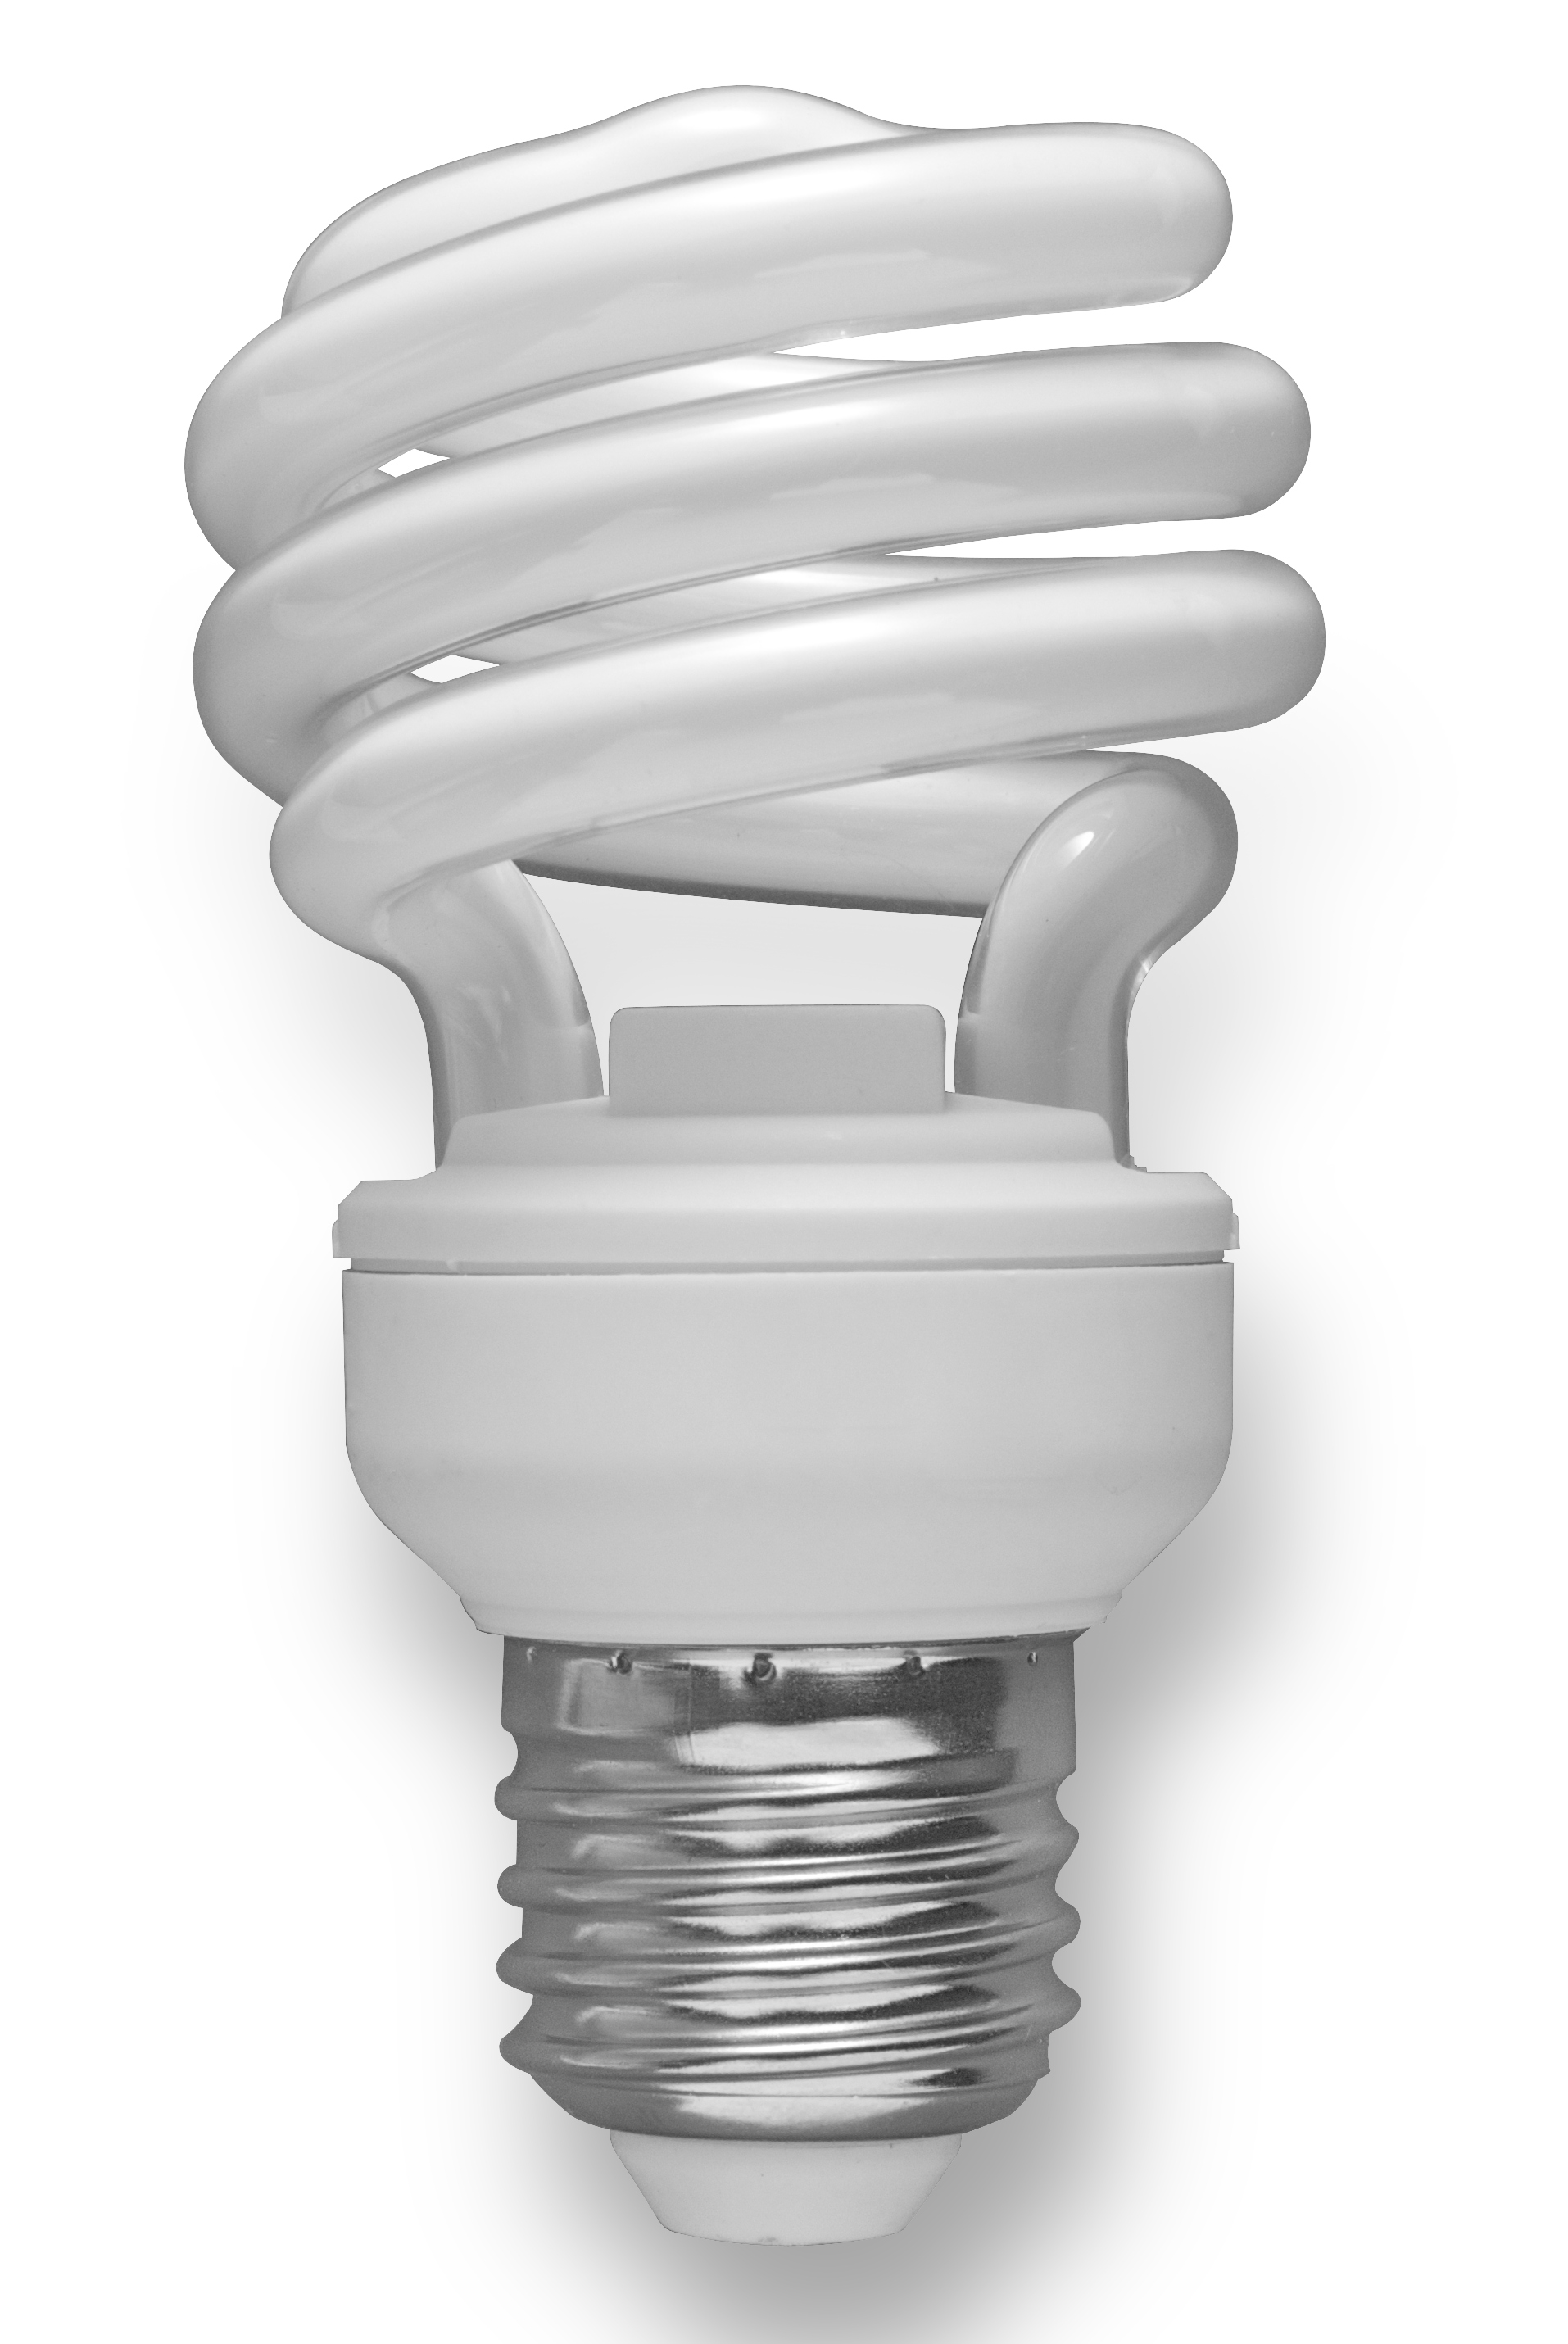
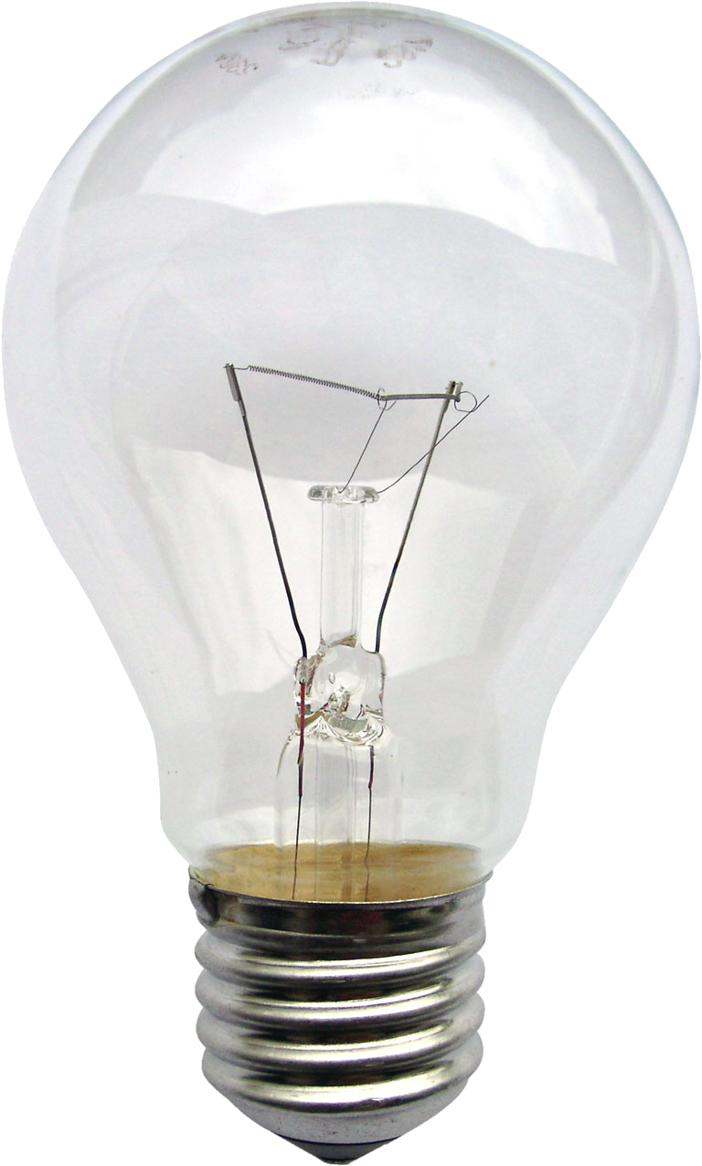
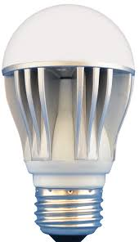

Incandescent Compact Fluorescent LED

Diagram the energy transfer when you turn on a light:

______________________ → _____________________ + ______________________

What kind of energy is “wasted” in this energy transfer? ________________

In this lab, you will be comparing the amount of light generated, energy used, and efficiency of two different types of light bulbs: incandescent (IC), and compact florescent (CFL). Consumers pay for the amount of energy used, which is the power (in watts) expended times the period of use (in hours), expressed in units of kilowatt hours (kWh).

The amount of energy required to operate a light bulb is divided between the energy needed to produce light, and the energy that is lost in that transfer, commonly as heat. Efficiency in a bulb is related to the percentage of light versus heat being generated by the bulb. The less heat being generated, the more efficient the bulb is at producing light.

Compact florescent bulbs are considered energy efficient. Replacing a single incandescent bulb with a compact fluorescent will keep half a ton of CO₂ out of the atmosphere over the life of the bulb. If everyone in the United States used energy efficient lighting, we could retire 90 average sized power plants.

Beginning Jan. 1, 2012, throughout the United States -- incandescent light bulbs must meet more stringent lumens/watt requirements. The bulbs must produce the same amount of lumens (brightness) for less wattage (energy). The changes begin with the 100 watt everyday incandescent light bulb, which must now use no more than 72 watts to produce a comparable brightness. Additional bulbs will be affected over the next several years. In 2007, then-president George W. Bush signed the Energy Independence and Security Act (EISA) into law. The provisions in this law are intended to reduce energy usage and greenhouse gas emissions and enable the United States to be less dependent on foreign sources of energy. One of the provisions provides for phasing out today's 40W, 60W, 75W and 100W general service incandescent light bulbs in favor of lower-wattage, energy-saving bulbs. Lighting accounts for about 15 percent of the electrical use in homes. The law also sets minimum standards for general service incandescent bulbs, making it necessary for consumers to replace the popular incandescent bulbs with more energy-efficient versions.
Additionally, new packaging requirements in the U.S. will change the way we refer to light bulbs. Instead of buying a "72 watt light bulb," we will now purchase a "1500 lumens light bulb" or "2500 lumens light bulb."
Procedure:
  - Observe each of the light bulbs provided for the experiment and record information about the power requirements, lumens produced and light bulb life in Table 1.

Table 1: Comparison of Different Light Bulbs
 | Power (Watts) | Brightness (Lumens) | Bulb Life  (Hours)
Incandescent (IC)
Compact Fluorescent (CFL)
LED

- Take the temperature of the incandescent bulb BEFORE turning it on, and record in Table 2.
- Place the incandescent bulb in the socket, and plug it in.
- Turn on the bulb, and record the temperature of the bulb (°C) at time intervals of 1 minute for 7 minutes. Take temperature measurements at the surface of the bulb, at a distance of 5 cm from the bulb, and a distance of 10 cm from the bulb.

***Make sure the temperature stabilizes on the thermometer before recording. ****

- Record all data in Table 2.
- Turn off the bulb, and using paper towels, return the bulb to the box. CAUTION: The bulb is HOT!
- Repeat measurements for the CFL bulb OR LED bulb and record in Table 3.

Table 2: Incandescent Bulb Data
Incandescent Bulb | Surface Temp. (°C) | 5 cm Distance (°C) | 10 cm Distance (°C)
Initial Temperature
1 minute
2 minutes
3 minutes
4 minutes
5 minutes
6 minutes
7 minutes

Table 3: CFL OR LED Bulb Data
CFL or LED Bulb | Surface Temp. (°C) | 5 cm Distance (°C) | 10 cm Distance (°C)
Initial Temperature
1 minute
2 minutes
3 minutes
4 minutes
5 minutes
6 minutes
7 minutes

Analysis:
- Diagram the energy transfers that occur when you turn on a light, assuming your house gets electricity from a coal fired power plant.

- Graph #1: Graph the changes in surface temperature over time for each bulb. (Time on the X-Axis, Temperature on the Y-Axis). Be sure to label your axes with the appropriate units and provide a key for the symbols you use.

  - In terms of energy efficiency, what can be inferred from the graph?

  - The law of conservation of energy states that energy cannot be created or destroyed, it just changes form. What happened to the additional watts of energy that was used by the incandescent light bulb to produce the same amount of the light, in lumens, as the CFL light bulb?

- Graph #2: Graph the temperatures for the 7th minute at each distance for each bulb (Distance on X-Axis, Temperature at 7th minute on Y-Axis). Be sure to label your axes with the appropriate units and provide a legend.

  - How does the temperature change as you move away from the bulb?

  - Do you notice any difference between the two types of bulbs? Explain.

- Conservation is defined as changing your behavior to use less energy, whereas efficiency is performing the same task while using less energy through advancements in technology. For each of the following statements, determine if it is an example of conservation or efficiency. Write C for Conservation and E for efficiency.

_____I purchased a Toyota Prius to replace a min-van.
_____I ride my bicycle on errands that are less than 1 mile from my house.
_____I changed jobs so that I work closer to my house.
_____I take shorter showers.
_____I air-dry my clothes instead of using a dryer.
_____I added insulation to my house to reduce drafts.

- Provide an example of conservation and efficiency for lights/ light bulbs.

- Is it possible to be efficient, yet not conserve? Explain your reasoning.

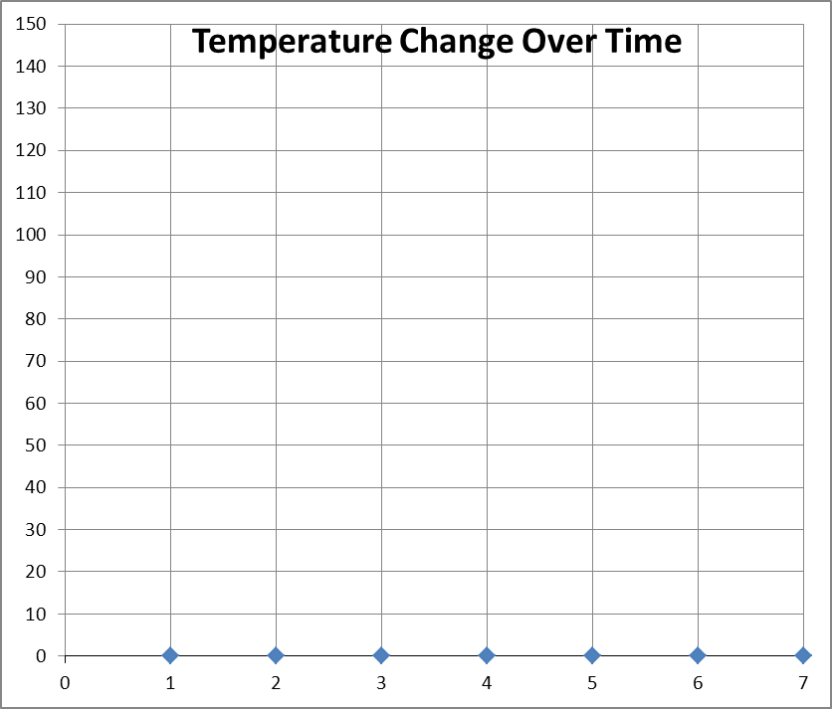
For help with this graph, see analysis question #2

KEY

= Incandescent

= CFL or LED

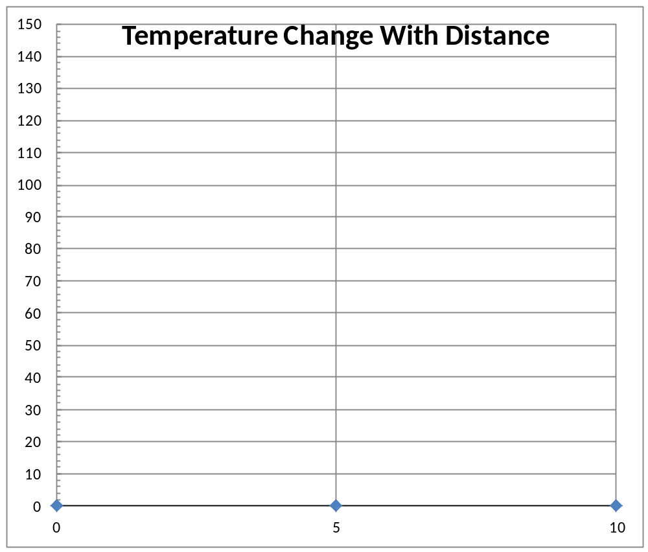
Label the X and Y axis on both graphs!!
For help with this graph, see analysis question #3

