NAME __________ Block ______ Binder Page #______

**Moon Phase Finder Questions**

Use your finished chart to answer the following questions.

* 1. From the diagrams below, identify the phase of the Moon and the number of days after the New Moon:

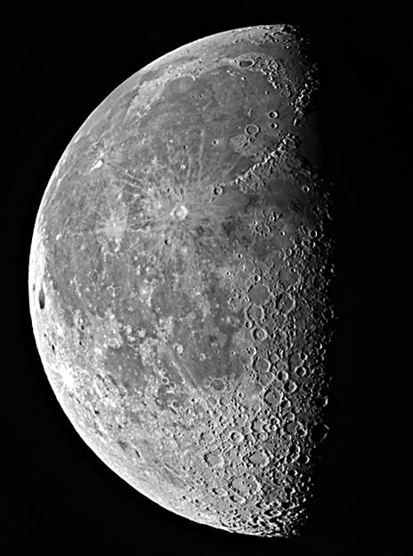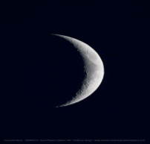

(a) Phase _______ (c) Phase ______

Day _______ Day ______

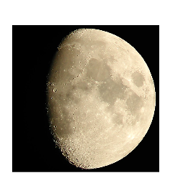

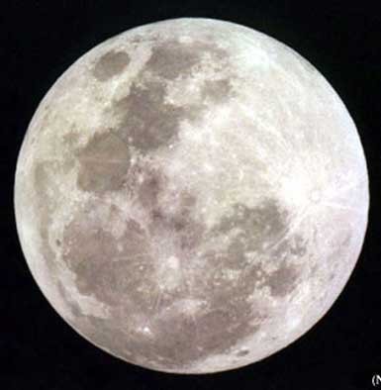

(b) Phase ______ (d) Phase ______

Day ______ Day______

* 1. (a) Refer to the predictions you made in Questions 5.1. Compare your picture sequence with the phase drawings on Chart 5.1. Make corrections as needed.

+

(b) Write the phase name under the appropriate photograph on the first page.

(c) Answer question 5.2 on the first page.

* 1. If you were to see the first quarter Moon today, what phase would you see two days later?
  2. At the first quarter Moon, does the Moon appear to the left or to the right of the Sun?
  3. At the first quarter Moon, is the apparent angle between the Sun and the Moon greater than, less than, or equal to 90 degrees?
  4. If the Moon were in its last quarter phase, in what phase would the EARTH appear to be if you were standing on the Moon?
  5. If you were standing on the Moon and saw the EARTH in its full phase, in what phase would the Moon be?
  6. If you looked at the horizon and saw the Full Moon just rising, where would you look to see the Sun?
  7. An inmate is planning to break out of prison. On August 2nd the prisoner sees a first quarter Moon. The inmate has read “Basic Escape Planning” by O. VerderWaal and knows that getting caught is what ruins most escapes. A dark night would help him avoid detection. Based on the Moon phase sighting above, on what date should the prisoner try to get out? Explain your choice of date. (This is only one example of how your study of the Moon’s phases may be useful to you later in life.)
  8. If you saw only a picture of the Moon, how could you tell where the Sun was when the picture was taken?
  9. Is the Full Moon ever visible during the daytime? If so, at what times?
  10. If the Moon were to set at 3 p.m., what would be its phase?
  11. If the Moon were rising at midnight, what would be its phase?
  12. If the Moon were at its highest at 9 p.m., what would be its phase?
  13. When does the last quarter Moon rise?
  14. When does the waxing crescent Moon set?
  15. If the Moon were full, at what time of day would it be highest in the sky?
  16. From the diagram below, identify the phase of the Moon and the approximate time of day:

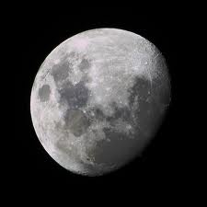

Phase ____________

Time ______

E S W

W