Name ___________________________________ Block ____ Binder Page # ____
PLATE TECTONICS SIMULATION
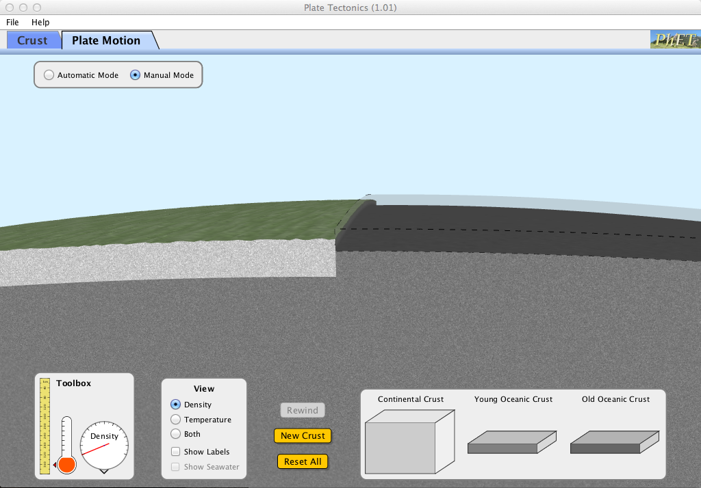
- Go to http://phet.colorado.edu/en/simulation/plate-tectonics
- Click on “Run Now”
- Click on the tab in the upper left corner “Plate Motion”
Answer the following questions before starting the simulation.
- Name the type of plate boundary:
  - When two plates move towards each other =
  - When two plates scrape past each other horizontally or vertically =
  - When two plates move away from each other =
- Drag types of crust from the bottom to the earth’s surface. Then, move the lever in the direction you want to move the plate. Hold it until the plates stop moving. Use the simulation to help you fill in the chart. You can start over with new types of crust by clicking the yellow “New Crust” button.
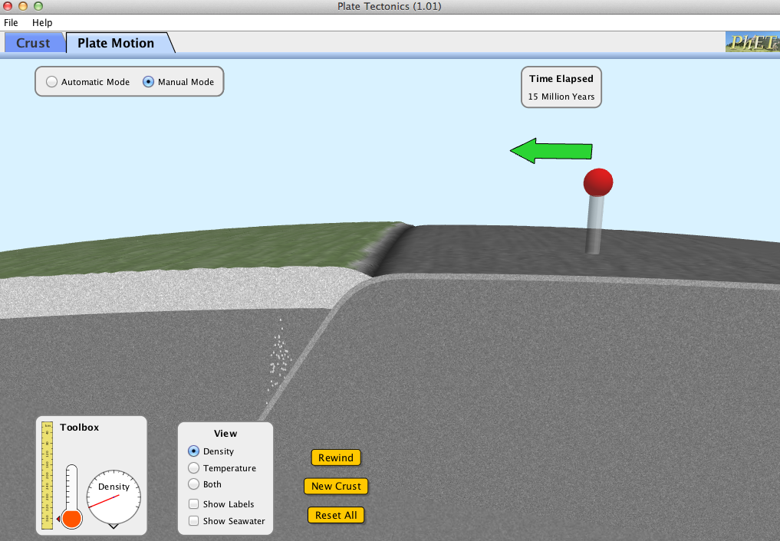
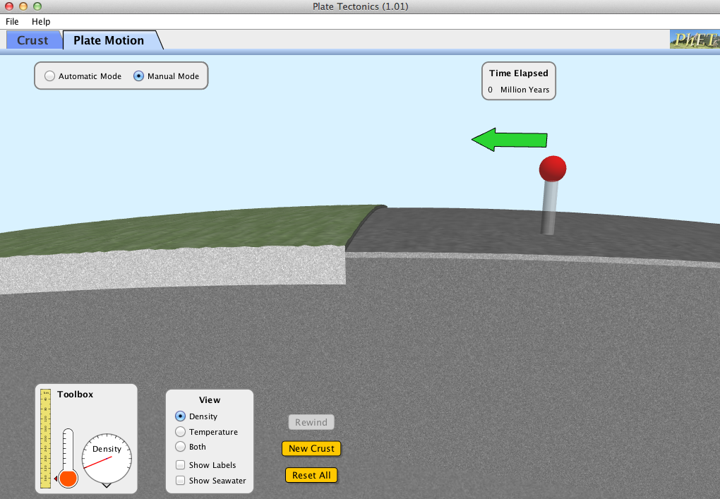

Type of boundary |  | Draw it!  Use ’s to indicate the direction of plate movement. Label the types of crust and features. | Use your words!
Convergent | Continental Crust Meets Oceanic Crust |  | Describe plates’ movement:  Describe the features that you find at this type of boundary:  Which plate subducts (goes under the other) and why?
Convergent | Continental Crust  Meets Continental Crust |  | Describe plates’ movement:  Describe the features that you find at this type of boundary:
Convergent | Young Oceanic Crust  Meets Old Oceanic Crust |  | Describe plates’ movement:  Describe the features that you find at this type of boundary:  Which plate subducts (goes under the other) and why?
Divergent |  |  | Describe plates’ movement:  Describe the features that you find at this type of boundary:  Where does the new oceanic crust come from?
Transform |  |  | Describe plates’ movement:  Describe the features that you find at this type of boundary:

