Six Italian Scientists Acquitted of Manslaughter From 2009 Earthquake
November 10, 2014 | by Lisa Winter
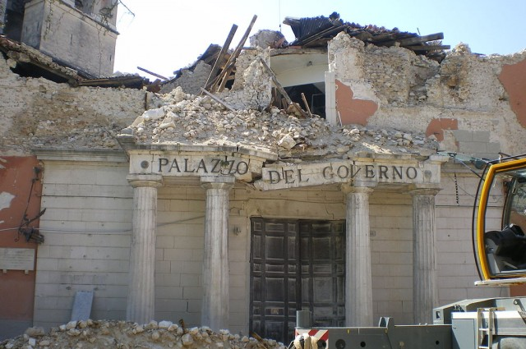photo credit: TheWiz83 via Wikimedia Commons
Share on facebook? Share on twitter57 Share on reddit Share on google_plusone_share More Sharing Services
The small city of L’Aquila in Southern Italy was hit by a 6.3 magnitude earthquake on April 6, 2009 that left 309 dead. Controversy arose due to the fact that a panel of scientists with Italy's National Commission for the Forecast and Prevention of Major Risks had been in the town a week earlier and told citizens that there was a low risk for earthquakes and evacuation would not be necessary. This error resulted in involuntary manslaughter convictions for seven scientists in 2012 with a sentence of 6 years in prison and fines to pay for $10 million for damages the earthquake inflicted.
In a new development, an appellate court in Rome has just acquitted six of those seven scientists. The conviction stood for hydraulic engineer Bernardo De Bernardinis, but his sentence has been reduced to 2 years in prison. At the time, De Bernardinis was the deputy head of the Civil Protection Department (DPC), which gave citizens advice based on input from the scientists. The court was able to find evidence that some victims who had previously intended on evacuating their homes had changed their minds once they heard De Bernardinis’ recommendation.
The conviction and sentencing of those scientists sparked outcry from the internationalscientific community. It is notoriously difficult to predict earthquakes or to give even 10 seconds of advance notice prior to an earthquake, so punishing a panel of scientists for being wrong a week ahead of time struck many as being categorically unjust. However, the judge at the time claimed that they were not being convicted for not predicting the earthquake, but he claims the scientists did not thoroughly investigate the risk, failing in their duty to protect the public.
Seismologist Giulio Selvaggi made a statement to the court on the final day of the trial. He described his 30 years of experience in the field and how it is essentially impossible to accurately predict earthquakes. Though L’Aquila was in an area that had the highest risk at the time, there was no way to predict when or if an earthquake would actually occur. For that reason, Selvaggi said that if he had to do it all over again, his recommendation for people to remain in their homes would have been the same. At the time, Selvaggi worked for Italy's National Institute of Geophysics and Volcanology (INGV).
“However, the conscience of having spoken with scientific rigor and with honesty does not attenuate, as in the past, my grief for the victims of this earthquake,” he told the court.
The other five scientists acquitted include:
- Enzo Boschi, geophysicist and then-president of INGV
- Gian Michele Calvi, seismic engineer
- Mauro Dolche, seismic engineer and then-director of seismic risk of DPC
- Claudio Eva, seismologist.
Though many in the scientific community are rejoicing that this conviction has been overturned, the families of the earthquake victims met the news with tears and outrage. A man who lost his son in the L’Aquila earthquake told The Repubblica that “we killed them again” by removing the sentences.

