Name ______________________________________
Block ________________
Reitsma – Earth Science Spring 2017 REVIEW…..
Origins of Astronomy – Part 1: Please Review the Tests/Quizzes #37, #51 and #58
What are Galileo’s 5 discoveries?
Light Year –
Parsec –
Astronomical Unit –
Stellar Parallax –
Retrograde Motion –
Earth’s Rotation –
Earth’s Revolution –
Universal Law of Gravitation –
What are Kepler’s 3 Laws?

What 2 gases make up most of the sun?
What is the difference in frequency and direction of a star with Blue Shift? Red Shift?

Radio waves – how much energy? Frequency? Length of waves?
x-rays – how much energy? Frequency? Length of waves?
Sun converts _________________- to __________________
How is the color of a star determined?
What 2 forces are acting in a star to keep it from exploding?
How do stars produce energy?
What is the difference between continuous and emission spectrum?

Describe the Doppler Effect.

What are sunspots?

How can you tell the elements that a star contains?

Use an H-R Diagram to identify where….. main Sequence / white dwarfs / red giants / Super Giants
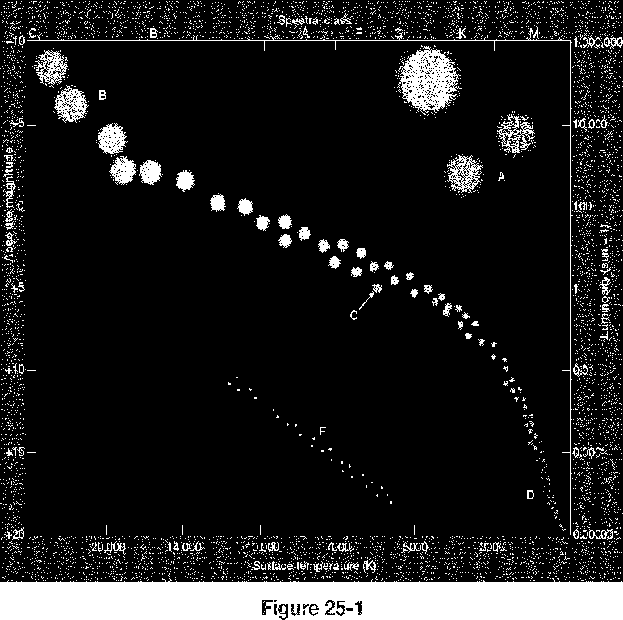
F
G

How do H-R diagrams plot stars?
What type of star is our sun?
Which color of star is the hottest? Coolest?

Geocentric vs Heliocentric
Inertia vs gravity

Black Holes vs Nebulas – Where will our sun end up? Where will a red super giant end up?(think life cycle of a star…)

Weather – Study all Quiz questions - #64
Why do we have seasons?

Main factors determining the amount of sunlight we receive during the year?
-
-
Where on earth is most / least light reflected? Why?

Radiation and House color – why?

Conduction, convection, radiation – what are they and how do they work?
-
-
-
Greenhouse effect – how does it work???
Greenhouses…
Earth…

Why is the ocean thought of as a heat sponge?

Ocean versus inland temperatures – why the difference?

Relative Humidity vs Temperature – When temp goes up…….
When temp goes down …
Tool we used to find relative humidity –
Dew point –
Relative humidity level at the Dew Point is…
What is relative humidity?

Positive feedback loop – what is it and examples?

Negative feedback loops – what is it and examples?

Temperature versus elevation

Pressure versus elevation

Warm air versus cold air – which can hold more moisture?

Difference between rain and frost – why does each form?

