Name _____________________________Block_____ Page # ____________

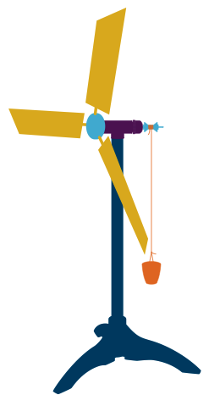
Windmill Lab: Investigating Variables and Power ________________Block__

Learning Goal:
Students will conduct a controlled experiment to maximize the power output of a windmill.

Pre-lab:
As a lab group/ class, discuss the following:

- List all variable(s):
- __________________________________
- __________________________________
- __________________________________
- __________________________________
- __________________________________
- __________________________________
- __________________________________
- __________________________________
- __________________________________

- Choose one of the variables listed above as your independent variable. ___________________________________

- Dependent Variable: __________________________________

- Variables you will keep constant in your experiment. These things will stay the same every single trial:
- _____________________________________________________________
- _____________________________________________________________
- _____________________________________________________________
- _____________________________________________________________
- _____________________________________________________________
- _____________________________________________________________
- _____________________________________________________________
- _____________________________________________________________

- Is your independent variable qualitative or quantitative (Circle one)? Are the measurements you take on the dependent variable quantitative or qualitative (Circle one)?

- Based on your answers to #5, what kind of graph would you make? … Bar Graph or Line graph with a trend line

- Write a hypothesis for your experiment: (If..then..because..) ________________________________________
_______________________________________________________________________________________________

- As a group, write a controlled, reproducible procedure. Read the “Need to Know” section below before you start writing the procedures. Everyone in the group must have their own copy of the procedures and data table.

“Need to Know” Equations:
To calculate how much energy is required to lift the washers, you must first measure the mass of the washers in kilograms as well as how high your windmill lifts the washers in meters. If your windmill cannot lift the washers to the top, you must reduce the number of washers in the cup.
Energy (Joules) = Mass (kg) X Acceleration of Gravity (9.8 m/s²) X Height (0.5 m)
To measure power, you must measure how long it takes to lift the washers to the top in seconds.
Power (Watts) = Energy (Joules)
Time (Seconds)

Procedures:

Data Table:
Trial: Describe IDV | # of Washers lifted | Mass of washers  (# x 14.5 ÷ 1000)  (Kg) | Time to lift washers (Sec) | Power  (W)
1.____________________________
Control Group
2..
3..
4..
5..
6..
Calculations: To calculate the power of the windmill each trial, use the formula below.
Power (W) = Mass (kg) X Acceleration of Gravity (9.8 m/s²) X Height (m) ÷ Time (sec)

Trail #1 = _______ kg X 9.8 m/s² X 0 .5 m ÷ _______sec = _________ W

Conclusion:

- Did the results of your experiment support or refute your hypothesis?

- Which trial was the most effective at generating power (describe the independent variable)?

- Describe any possible errors in your experiment (Please don’t include things like, “We might have measured incorrectly.”):

- How would you improve this experiment to avoid the errors listed in question 10?

- Listen to other groups present their experiment and take notes on the most effective designs for other variables:
___________________________________________

- Combining the information from your experiment as well as other groups’ experiments, draw and label the most powerful windmill you could make with the materials we have in class.

