Energy Transformations Name ________________ block __ Binder # _____
Video Notes

Energy is the ability to do work, create motion, or cause change in matter.

The two categories of energy are Potential and Kinetic.

For each type of energy listed below, describe it, and give an example.

- Types of Potential Energy:
  - Chemical: Fuels (gas) and food (cake) and batteries
  - Nuclear: Energy stored in the nucleus of an atom (bomb)
  - Stored Mechanical (Also called Elastic Potential): materials are stretched or squashed (rubber band)
  - Gravitational: Object is lifted up (weights)
- Types of Kinetic Energy:
  - Radiant: electromagnetic energy (light)
  - Thermal: stored in a hot object (lava)
  - Motion: movement of materials (cars. wind, rivers)
  - Sound: Movement of Noise energy (speakers and music)
  - Electrical: flows along wires in a circuit (lights)

The Law of Conservation of Energy states that…

Energy cannot be created or destroyed. Energy is converted from 1 form to another.

An example of the Law of Conservation of Energy is (Draw/Explain)...

Sun ----------> Carrot Energy from the sun is converted into
(Nuclear/Radiant) (Chemical) chemical energy in the carrot

Where did the energy in your food come from?
From the Sun
How is energy converted from one form to another when you drive car? (Draw/Explain)

Gas ----------- Burned ---------- Motor Turns -------- Car Moves
(Pot-Chemical) (Kin-Thermal) (Kin-Motion (Kin-Motion)

Describe the energy transformation that is taking place in each scenario.

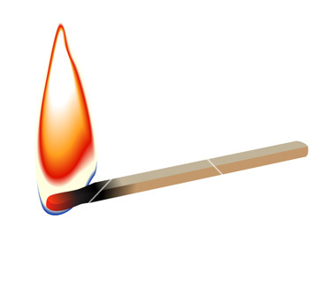
Lighting a match

Pot-Chemical Kin-Thermal (heat) and Kin-Radiant (light)

Exploding Fireworks

Pot-Chemical Kin-Thermal (Heat) and Kin-Radiant (light) and Kin-Sound

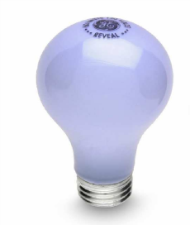
Turning on a lightbulb

Kin-Electric Kin-Thermal (heat) and Kin-Radiant (light)

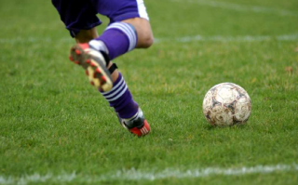
Kicking a soccer ball (start with the energy the foot)

Kin-Motion (foot) Kin-Motion (ball) and Kin-Thermal (heat) and Kin-Sound

Learning Checks: NOW YOU TRY!

- ___________________________________________________________________________
- ____________________
- ____________________
- ____________________

