Name ____________________________________________________________ Block ___________ Binder Page # ______
Relative Dating Practice Activity #1
1. What is the Oldest Layer? __________ 3. What is Younger – “R” or “S”? _________ Law - _______________
2. What is the Youngest Layer? __________ 4. Place all the layers (and Erosion) in order, from Oldest to Youngest.
_____________________________________________________________

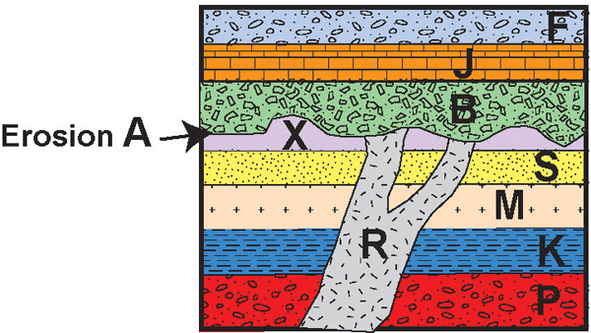
Relative Dating Practice Activity #2
1. What is the Youngest Rock Layer? _______________ 2. What is older, “F” or “M”? ________
Law? _____________________________
3. What is the Oldest Rock Layer? _______________ 4. What is younger, “H” or “R”? ________
5. Place all the layers, fault, intrusion, and erosions in order, from Oldest to Youngest.
Oldest (first)_____________________________________________________________________ Youngest (last)

