Energy is the ability of a system to do work. Energy is in everything. We use energy for everything we do, from making a jump shot to baking cookies to sending astronauts into space. Energy comes in different forms and can be divided into different categories.

- Thermal
- Radiant
- Motion
- Electrical
- Sound
- Chemical
- Nuclear energy
- Gravitational
- Mechanical

There are two types of energy:
Stored (potential) energy
Working (kinetic) energy
Some forms of energy can be partly kinetic and partly potential energy. For example, the food you eat contains chemical energy, and your body stores this energy until you use it when you work or play.

The energy in a system or object that results in its temperature is called thermal energy. When there is a net transfer of energy from one system to another, due to a difference in temperature, the energy transferred is called heat. Heat transfer happens in 3 ways: convection, conduction, and radiation. Like all energy transfer, heat transfer involves forces exerted over a distance at some level as systems interact.

One key principle of energy is the law of conservation of energy. It states that energy cannot be created or destroyed. The change in the total amount of energy in a system is always equal to the difference between the amount of energy transferred in and the amount transferred out. The total amount of energy in the universe is finite and constant.

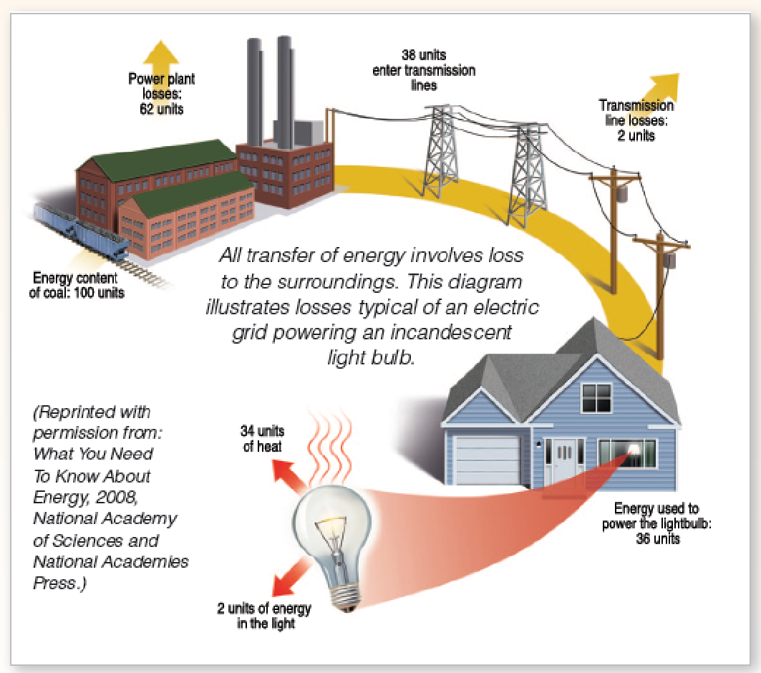
The amount of energy available to do useful work decreases as it is transferred from one form to another or from one object to another. During all transfers of energy between two systems, some energy is “lost” to the surroundings. In a practical sense, this lost energy has been “used up” even though it is still around somewhere. It has simply been transferred to an unintended form. The efficiency of an energy transfer is a measure of how much of the starting energy is transferred to the intended form of energy. A more efficient system will lose less energy, up to a theoretical limit.

The diagram to the right is an example of efficiency. The original energy content of coal was 100 units. As coal is converted into electricity (the intended transfer), a large part of the original chemical energy is lost to unintended forms such as thermal. By the time the electricity is used by a lightbulb to produce light, only 2 units of energy remain. 98% of the original chemical energy has been “lost” by various unintended transfers along the way.
There are many different units that are used to quantify energy. For example, joules, calories, ergs, kilowatt-hours, and BTU’s are all units of energy. Power is a measure of the energy transfer rate. It is useful to talk about the rate at which energy is transferred from one system to another (energy per time). This rate is called power. One joule of energy transferred in one second is called a Watt (ie. 1 joule/second = 1 Watt).

The quality of life of individuals and societies is affected by energy choices. Economic and national security is affected by energy choices; price fluctuations, instability, and energy dependence. For example, a nation that has diverse sources of energy within its borders is more secure than a nation largely dependent on foreign energy supplies. As of 2011, there were 1.3 billion people on the Earth with no access to electricity.

Our energy choices also impact environmental quality. The quality of life of humans and other organisms that live on the Earth can be significantly affected by our energy choices. Every type of energy has cost and benefits associated with its use.

Energy sources can be categorized as renewable or nonrenewable. When we use electricity in our home, the electrical power was probably generated by burning coal, by a nuclear reaction, or by a hydroelectric plant at a dam. Therefore, coal, nuclear and hydro are called energy sources. When we fill up a gas tank, the source might be petroleum or ethanol made by growing and processing corn.

Energy sources are divided into two groups — renewable (an energy source that can be easily replenished) and nonrenewable (an energy source that we are using up and cannot recreate). Renewable and nonrenewable energy sources can be used to produce secondary energy sources including electricity and hydrogen.

Renewable energy sources include:
Solar energy
Wind
Geothermal energy from heat inside the Earth
Biomass from plants, which includes firewood from trees, ethanol from corn, and biodiesel from vegetable oil
Hydropower

We get most of our energy from nonrenewable energy sources, which include the fossil fuels — oil, natural gas, and coal. They're called fossil fuels because they were formed over millions and millions of years by the action of heat from the Earth's core and pressure from rock and soil on the remains (or "fossils") of dead plants and creatures like microscopic diatoms. Another nonrenewable energy source is the element uranium, whose atoms we split (through a process called nuclear fission) to create heat and ultimately electricity.

Increasing demand for and limited supplies of fossil fuels affects quality of life. Currently, fossil fuels provide a vast majority of the world’s energy. Fossil fuel supplies are limited. If society does not transition to sources of energy that are renewable before depleting Earth’s fossil fuel supplies, it will find itself in a situation where energy demand far exceeds energy supply. This situation will have serious social and economic consequences. Increased consumption, climate change, and worldwide population growth are causing increasing stress on our energy supply. Due to these challenges, society will need to focus on reducing waste and increasing energy efficiency.
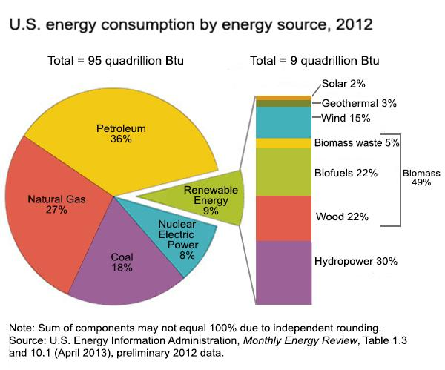

The chart above shows what energy sources the United States used in 2012. Nonrenewable energy sources accounted for 91% of all energy used in the nation. Biomass, the largest renewable source, accounted for about half of all renewable energy and 4% of total energy consumption.

How much energy does a person use in a year?

In 2011, total energy use per person (or per capita consumption) in the United States was 312 million British thermal units (Btu) which declined 1.3% compared to the prior year. It was 13% less than the per capita consumption in 1978, which was the highest since 1949. The world per capita consumption of energy1 in 2010 was 74 million Btu.

How much of the world's energy does the United States use?

In 2010, world total primary energy consumption was 511 quadrillion Btu. The United States' primary energy consumption was nearly 98 quadrillion Btu, nearly 19% of world total primary energy consumption. As of 2012, the United States contained 4.5% of the world’s population.

